BCMA Practitioner Register Website Listing Form
Please fill in your details below clearly in black ink and printed capitals

Country

County

Town/Area

Postcode (first part only i.e. BH8) _______

Name
(as you would like it displayed)

BCMA member organisation/school

Telephone number for display on website

Email Address

Your Website

Therapies for which you are fully qualified and insured and sponsored by the above BCMA school.

Any other therapies should be marked as independent below and copies of your qualifications and insurance must be included for these and sent to the BCMA office

Example of listing
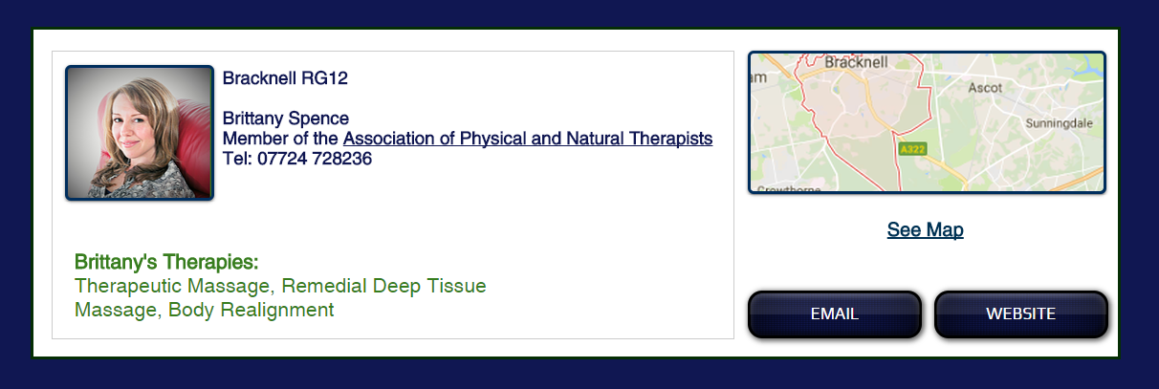
Please send a profile picture or URL of your picture if you would like it included to tracy@bcma.co.uk

