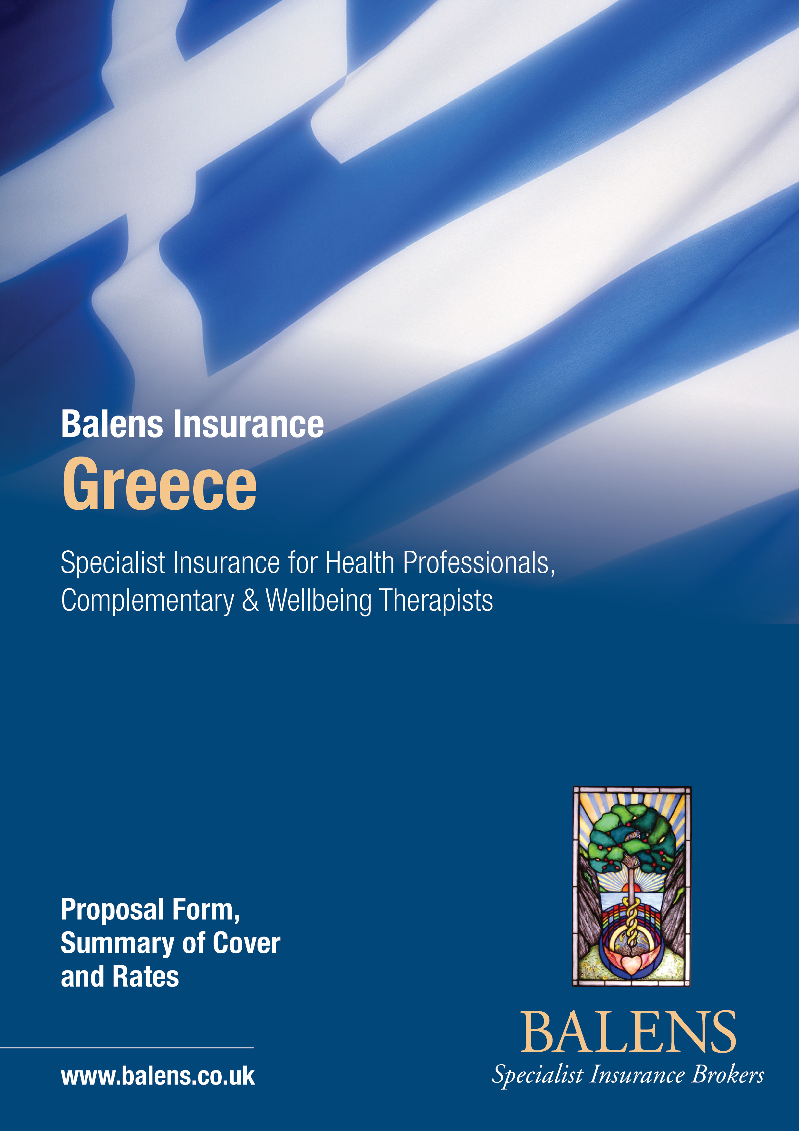

Who are Balens..?
- Balens are a well Established, fourth generation, family-run business which has been built on solid roots going back to 1950, and have grown during that time to its’ present size mainly through recommendation.
- We were Pioneers in the development of top quality cover, at a time when these were not easily available, for Health Professionals specialising in Complementary Therapists with special rates and industry leading cover. We have been developing and improving our range for over 21 years in this speciality – often copied, never bettered!
- When you deal with Balens you will receive expert advice and claims service from one of the largest independent Natural Health Professional Specialist Brokers in Europe.
- We offer consultancy and a Personal Approach in these days of growing impersonality and aim to offer a friendly, listening approach to our clients’ needs.
- We are an ethical company dedicated to customer care and are not solely motivated by profit.
What can we offer..?

- Balens are Market Leaders in development and improvement of wordings for Natural Medicine & Wellbeing Professionals. Our policy wordings are the widest available on the market and include important features that other insurance packages on the market may not include. For example in addition to Malpractice, we cover Professional Indemnity, Public / Products Liability, Breach of Confidentiality Allegations of Breach of Intellectual Property allegations of sexual assault etc against you.
- Premiums are very competitive, cover is very comprehensive.
- We can also insure your premises and contents if required and have Personal Accident cover available.
- All types of Comprehensive Insurance solutions for Complementary Medicine & Wellbeing Therapists, Medical Auxiliary Professionals, Health-related Businesses, Organisations, Beauty Therapy Professionals and many other Health Professionals on an individual basis or as part of a customised block scheme arrangement.
- European policies are designed to comply with local Legislation. Our European clients get local service, in a local language where required.
- We offer Sympathetic and expert help in event of an incident occurring from specialist intermediaries. Our experience in helping lift the burden and giving skilled advice to avoid problems when we are advised of a possible claim circumstance is second to none, and we would place this feature above all others. At the time when you need it most, and when you feel vulnerable, we are there to support you. Our approach is different in that we will help you deal with these initially without resort to solicitors, and our Insurers will not just pay a claim quickly to reduce their costs, as can easily happen. Practitioners want their version of a case to be considered. Their reputation, and of course the reputation of the Therapy, could be affected as a result of claims paid for as a matter of expediency.
- Many well-known and respected organisations use our services. David Balen is an advisor to Professional Bodies on Insurance and Practice Management Issues, and lectures and writes articles for journals regularly.

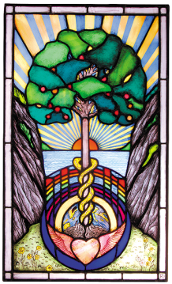

BALENS
What is covered..?
- Medical Malpractice, Professional Indemnity, Errors and Omissions.

- Unlimited trips abroad anywhere in the World excluding USA and Canada.

- Public Liability = Bodily Injury, to any person, or 3rd Party Property Damage.

- Products Liability = Bodily Injury to any person and/or 3rd party Property Damage, arising from the sale or supply of any Medicines. Includes Liability for injury caused by Products. Unlimited product sales to your clients and up to €30,000 to non-clients.
- Wide range of activities can be insured from the non-invasive to the more invasive types, as well as non-treatment related work and advice.
- Damages and claimant’s costs as a result of any Claim.
- Legal costs and expenses included and in addition to the limit of indemnity.
- Loss of Documents / Loss of Reputation.
- Libel & Slander, Breach of Confidentiality, Unintentional Breach of Confidentiality or Privacy.
- Unintentional breach of copyright or any other intellectual property right.

- Includes cover for Teaching, providing you are not issuing a Certificate of qualification.

- Good Samaritan Acts and First Aid.

- Limit of Indemnity of €500,000
- Sexual Harassment Defence Costs if innocent.
- Excess each claim €0.
- Retroactive cover for previous work performed.
- Run-off Cover automatically included – no need to keep your policy going if you stop it. Covers late discovered claims.
- Flexible underwriting to accommodate changes in your practice.
- Multi therapy policy – over 3,000 different therapies can be included, most at no extra cost.

THIS IS A SAMPLE OF THE THERAPIES WE COVER:-
Class 1
Ancient Rainbow Conscious Healing (ARCH) | Energy Healing (Non-Contact)
Angelic Reiki (Including Animals) | Healing (Including Animals)
Block Clearance Healing | Reiki (Including Animals)
Crystal Healing | Seichem Healing
Egyptian Healing | Spiritual Healing (Non-Contact)

Class 2
Acupressure | Energy Balancing
Alexander Technique | Enneagram
Angel Therapy | Eye Movement Desensitisation Reprogramming (EMDR)
Allergy Testing Therapy | Feldenkrais Method
Aromatherapy | Feng Shui
Astrology | Five Rhythms Dance Teachers
Aura-Soma | Flower Essences and Remedies
Ayurveda Massage | Golf Biomechanics
Bach and Australian Bush Flower Remedies | Gyrotonics
Bates Method | Hakomi Therapy
Best System | Hand Reflexology
Bi Aura | Healthy Eating Advice
Bicom & Bioresonance | Hearing Therapy
Bio Dynamic Bodywork | Hellerwork
Bio Energy Therapy | Herbalism
Bio Magnetic Therapy | Holistic Re-Tuning
Bio Resonance Therapy | Homeopathy
Body Harmony | Hot Stone Therapy
Body Talk | Human Givens
Bowen Technique | Hydrotherm Massage
Breathing Therapy / Breathing Massage | Hyperton X
Buqi Healing | Hypnobirthing
Bush Remedies | Hypnotherapy
Buteyko | Indian Head and Face Massage
Chi Kung / Qi Gong | Integrated Energy Therapy
Clinical Hypnotherapy | Iridology
Cognitive Therapy | Kinetic Energy
Colour Therapy | Kinesiology
Counselling | La Stone
Craniosacral Therapy | Life Coaching
Creative Writing | Light Touch Therapy
Crystal Therapy | Lymphatic Drainage Category 1 and 2
Diet and Nutrition Advice | Meditation
Dowsing for Stress Release | Manual Lymphatic Drainage Category 1 and 2
Electro Acupressure | Massage (Including Deep Tissue)
Electro Crystal Therapy / Electro Gem Therapy | Meditation & Physic Awareness
Emo Trance / Therapy | Mentoring
Emotional Freedom Technique | Metamorphic Technique
Movement Therapy | Remedial Therapy and Remedial Massage
Muscle Energy Technique | Rolfing
Naturopathy | Seated Acupressure
Neuro-Linguistic Programming | Seiki Soho
Nutri Energetic System & Infoceuticals | Shamanic Healing
Nutrition | Shell Essence
On Site Massage | Shiatsu
Phytobiophysics | Skeletal Balancing
Phytotherapy | Sound Therapy
Pilates | Spiritual Psychotherapy
Polarity Therapy | Sports Injuries Massage / Therapy
Pranayama (Yoga Breathing) | Stress Management
Provocative Therapy | Tai Chi (Non-Combat)
Psychodynamic | Touch For Health
Psychology | Vega Testing
Psychotherapy | Vibrational Essences
Qi Gong | Vitamin & Mineral Therapy
Radiaesthesia (Form of Dowsing) | Voice and Movement
Radionics | Watsu
Reflex Zone Therapy | Yoga Teaching / Therapy
Reflexology | Zero Balancing
Relaxation Therapy
Class 3
Acupuncture | Eye Brow Tinting
Aerobics | Fitness Training
Antenatal Exercise | Gym Instructor
Aqua Detox | Hopi Ear Candling
Aquatic Fitness | Hydrotherapy
Auricular Acupuncture | Lash Tint / Dye & Eyebrow Shaping
Ayurvedic Medicine | Manicure and Pedicure
Baby Massage Instructor | Manual Lymphatic Drainage Category 3
 | Microdermabrasion
Balinese Massage | Moxibustion / Cupping
Bio Detox Therapy | Myofascial Release
Bio-Magnetic Therapy | Nail Care including Nail Extensions
Bio-Mechanic Therapy | Neuromuscular Therapy
Body Alignment Technique | Neurotherapy
Body Combat (Non-Contact) | Quantum QXCI
Child, Adolescent and Family Therapy | Skenar Therapy
Chinese Herbal Medicine | Spa Therapy
Dance Teacher | Sugaring
Depilation | Thai Yoga Massage
Dry Needling | Thermo Auricular Therapy
Electrical Epilation | Ultra Sound Therapy
Electro Magnetic Acupuncture | Waxing / Epilation
Exercise/ Fitness Instruction

Class 4
Animal Manual Therapy | Equine Therapies
Chiropody | Holistic Podiatry
Chiropractic | Micro Needling / Derma Rollering
Colonic Hydrotherapy | Osteopathy
Colonic Irrigation | Physiotherapy / Veterinary Physiotherapy

Premiums/Ασφάλιστρα

Limit | Class 1 & 2 | Class 3 | Class 4
€500,000 | €112.00 | €187.00 | Referral

15% Insurance Tax is included in the above premiums plus €20 - €21 Admin fee.

Payment Details
IF YOU WOULD LIKE TO PAY BY DIRECT BANK TRANSFER, PLEASE USE THE BELOW BANK DETAILS, OR YOU CAN PAY OVER THE PHONE BY CARD

ULSTER BANK, DUBLIN 6  ACCOUNT NUMBER: 16507189  SORT CODE: 98 50 50  IBAN No. IE80 ULSB 98505016507189  BIC/SWIFT CODE : ULSB IE 2D |  |  | BRIDGE HOUSE  PORTLAND ROAD  MALVERN  WORCS, WR14 2TA  Tel: 00 44 1684 – 580776

BALENS
Bridge House, Portland Road, Malvern, Worcs, WR14 2TA
Tel: 00 44 1684 – 893006 Fax: 00 44 1684 – 891361
Web: www.balens.co.uk Email: Europe@balens.co.uk
Version 1 – October 2017

Greek Insurance Scheme
Statement of Fact
Title/τίτλος:

Name/Όνομα : E-mail Address/Ηλεκτρονική Διεύθυνση:
Trading Name: (if different)

Address/Διεύθυνση: Telephone No/Τηλέφωνο:
Please state the nature of your practice/Σημείωστε πιο κάτω τις θεραπείες που εξασκείτε:
( ) Acupuncture/Βελονισμός  ( ) Allergy Testing/Αλλεργικό Τέστ  ( ) Aromatherapy/Αρωματοθεραπεία  ( ) Animal Therapy/Θεραπεία ζώων  ( ) Bach Flower Remedies/Ανθοϊάματα Μπαχ  ( ) Bowen Technique/Τεχνική Bowen  ( ) Colonic Irrigation/Υδροθεραπεία εντέρου  ( ) Colour Therapy/Χρωματοθεραπεία  ( ) Counseling/Συμβουλευτική  ( ) Craniosacral Therapy/Κρανιοθεραπεία  ( ) Crystal Therapy/Κρυσταλλοθεραπεία  ( ) Dry Needling technique/Tεχνική ξηράς βελόνης  ( ) Homeopathy/Ομοιοπαθητική  ( ) Hypnotherapy/Υπνοθεραπεία  ( ) Healing  ( ) Herbalism/Βοτανολογία  ( ) Indian Head Massage/Ινδικό μασάζ της κεφαλής  ( ) Iridology/Ιριδολογία  ( ) Kinesiology/Κινησιολογία | ( ) Massage/Μασάζ  ( ) Naturopathy/Φυσικοπαθητική  ( ) Neuro-Linguistic Programming/Νευρο-Γλωσσικός Προγραμματισμός  ( ) Nutrition Therapy/Διατροφική θεραπεία  ( ) Osteopathy/Οστεοπαθητική  ( ) Psychotherapy/Ψυχοθεραπεία  ( ) Physiotherapy/Φυσιοθεραπεία  ( ) Pilates/Πιλάτες  ( ) Polarity therapy  ( ) Reiki  ( ) Reflexology/Ρεφλεξολογία  ( ) Stress Counseling/Συμβουλευτική του Στρες  ( ) Sports Massage/Αθλητικό μασάζ  ( ) Tai Chi (Non-Combat)  ( ) Yoga Teaching Therapy or Therapy/Διδασκαλία Γιόγκα ή Θεραπεία
( ) Any other, please state or list/ Άλλη ειδικότητα ………………………………………………………………………….…...........................................................................................

Declaration

*I can confirm that:

- I hold professional qualifications in the above therapies and that I understand that if, in the event of a claim, I am unable to provide proof of my qualification(s), the insurance will not indemnify me.
- I am a current member of the BCMA.
- There have been no claims or suits for negligence, error or omission made against me, nor am I aware of any circumstances which may result in any such claim or suit being made against me.
- No insurer has even cancelled, declined or refused to renew or accepted on special terms my Professional Insurance.
- I have not, under current or any previous trading title, been convicted of any criminal offence, other than motoring and no prosecutions are pending.
- My income from insured activities will not exceed €100,000 per annum.
- I am not selling more than €30,000 of Products to non-clients.

I hereby declare and warrant that the above statements and particulars are in all respects complete and true and that I have not suppressed or misstated any material facts** and I agree that this Statement of Fact shall be the basis of the contract with the Insurers and deemed part of the insurance coverage.

Signature of Proposer: Dated:

* If you are unable to confirm the above statements, please explain why in a separate note.
** This means that you should disclose any relevant information relating to the above questions and not withhold or misrepresent any facts which are likely to influence the Insurer’s assessment and acceptance of this proposal. You have a duty to disclose any such facts and failure to do so could invalidate the insurance. A specimen policy wording is available on request at all times.

Please return your form to: baleneurobusiness@balens.co.uk
or Fax to 00 44 1684 891361
“Experts who care”

Established 1950, Authorised and Regulated by the Financial Conduct Authority.

Member of the Institute of Insurance Brokers

Balens Ltd. trading as Balens, registered in England & Wales, Reg.No. 4931050
Version 1 – October 2017

