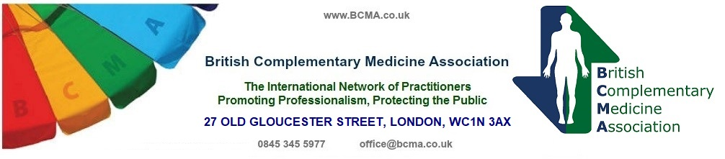

Sponsoring Organisation Declaration for
Graduate membership application.

(Please note: Sponsoring school/college must be a registered member of the BCMA schools register)

Please complete in full, in block capitals.

(This sheet may be photocopied)

The ________________________________________________________________
(name of member school/college sponsoring this graduate)

Confirms that (name of Graduate)

____________________________________________________________________

Has completed training with the above school and is now qualified to practice

____________________________________________________________________
(Name of therapy in which training is complete)

Signed and stamped on behalf of our School/College:-

____________________________________________________________________

CHAIR \ TREASURER \ SECRETARY

Print name(s)______________________________________Date____________________

This form must accompany the application for graduate membership

BCMA PO Box 5122, Bournemouth, Dorset, BH8 0WG

